Name :SK.Kashifa

Registration no :192121135

Online Internship

Class diagram :

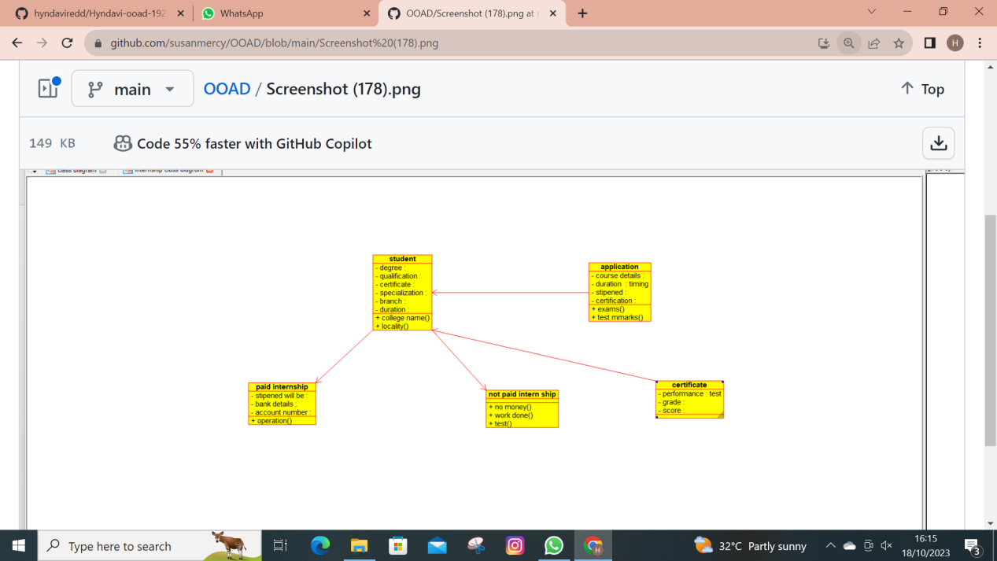

Use case diagram :

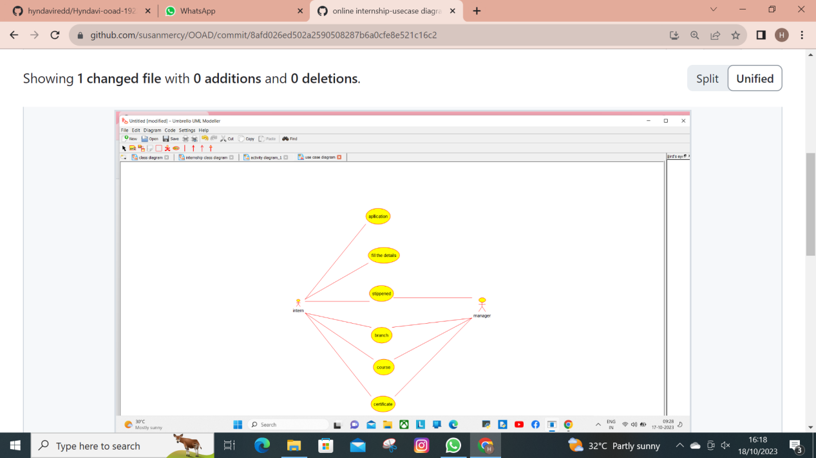

Activity diagram :

